**Output of Jobs­**

Click on screenshots to view larger image.

**Job #1** - counting the number of occurrences of words in a set of text files.

Reducers 1 and 3:

[C:\Users\Urvi\Desktop\536\PROJECT\WordCount_1_3.tiff](WordCount_1_3.tiff)

Reducers 2 and 4:

[C:\Users\Urvi\Desktop\536\PROJECT\WordCount_2_4.tiff](WordCount_2_4.tiff)

**Job #2 -**  the reverse index of proper names in Dickens’ novels. The output from the 4 reducers is shown on the following pages.

Reducer #1 output:

[C:\Users\Urvi\Downloads\Screenshots_Trial_2 (1)\CapitalWord_Reducer_1.tiff](ReverseIndex_1.tiff)

Reducer #2 output:

[C:\Users\Urvi\Downloads\Screenshots_Trial_2 (1)\CapitalWord_Reducer_2.tiff](ReverseIndex_2.tiff)

Reducer #3 output:

[C:\Users\Urvi\Downloads\Screenshots_Trial_2 (1)\CapitalWord_Reducer_3.tiff](ReverseIndex_3.tiff)

Reduce #4 output:

[C:\Users\Urvi\Downloads\Screenshots_Trial_2 (1)\CapitalWordReducer_4.tiff](ReverseIndex_4.tiff)

**Job #3 -**  computing the number of incoming hyperlinks for each html file in a set of html files

Reducers 1 and 3:

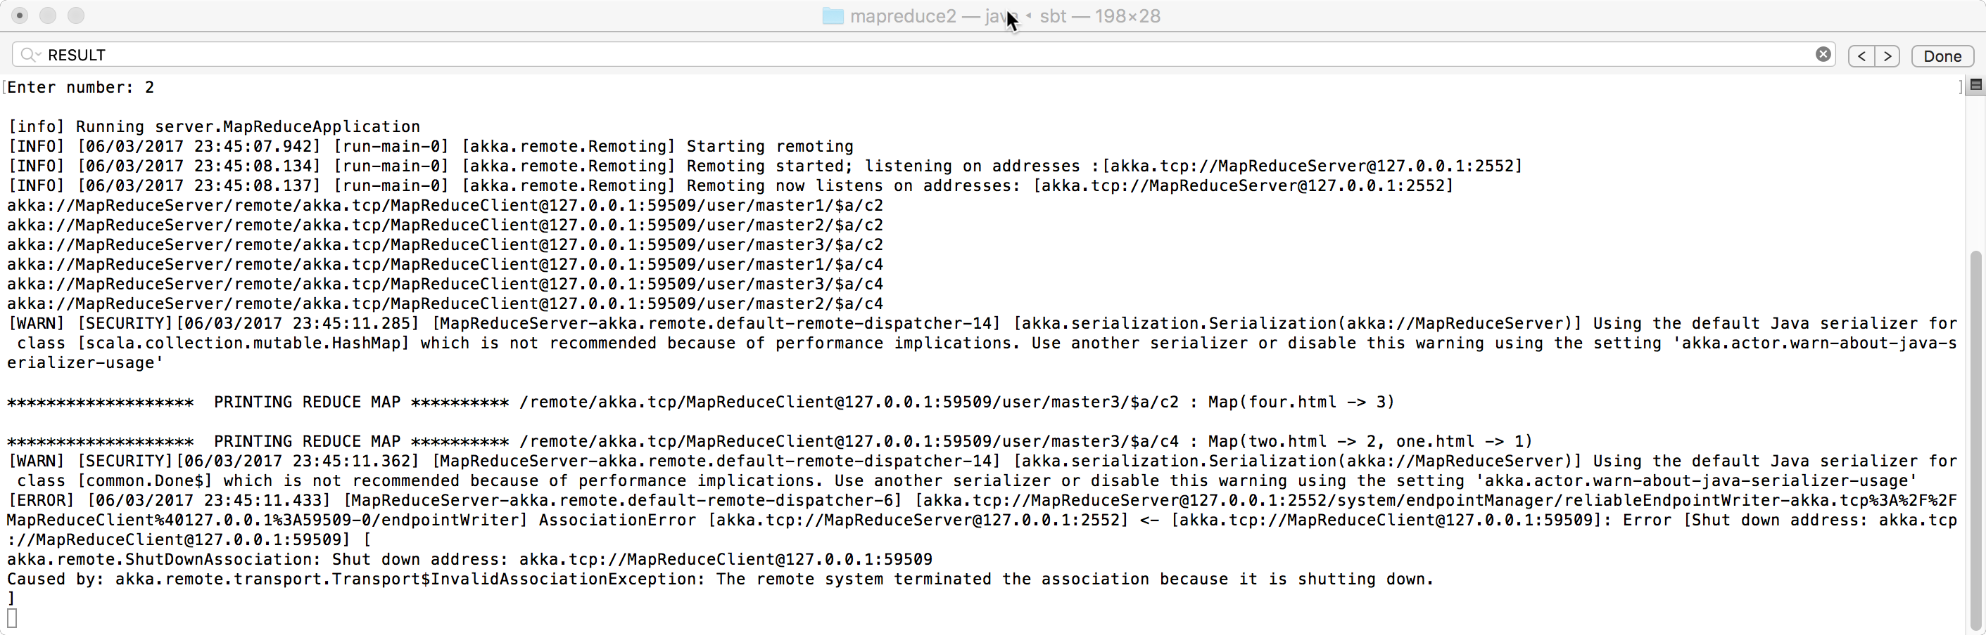

Reducers 2 and 4:

